Online Food Ordering System

-A.Sreeja

ABSTRACT

ONLINE FOOD ORDER SYSTEM is mainly designed primarily function for use in the food delivery industry. This system will allow hotels and restaurants to increase online food ordering such type of business. In this we create main modules like Administrator Module, Restaurant Module, Customer Module, Delivery Module using python and framework(Django).The Admin can handle the whole app or website like registration and user authentication.The customers can be selected food menu items just few minutes. In restaurant module the can handle all changes in the restaurant and update the changes like add food, delete food etc.In the modern food industries allows to quickly and easily delivery on customer place. Restaurant employees then use these orders through an easy to delivery on customer place easy find out navigate graphical interface for efficient processing.



UML Diagrams

Class Diagram:

Customer

Name

Address

Number

Admin

Name

Email id

Order

Food category

Quantity

Payment

Select payment type( gpay,

phonepay,CoD)





Delivery agent

Delivery person name

Delivery status

contact

Use Case Diagram

Admin Customer Sequence Diagram

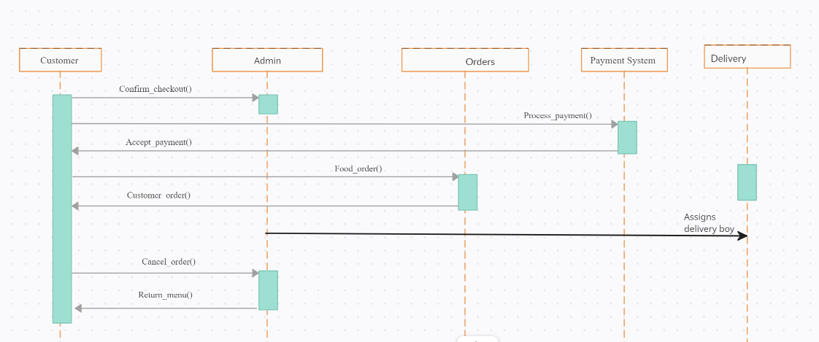

Data Flow Diagram

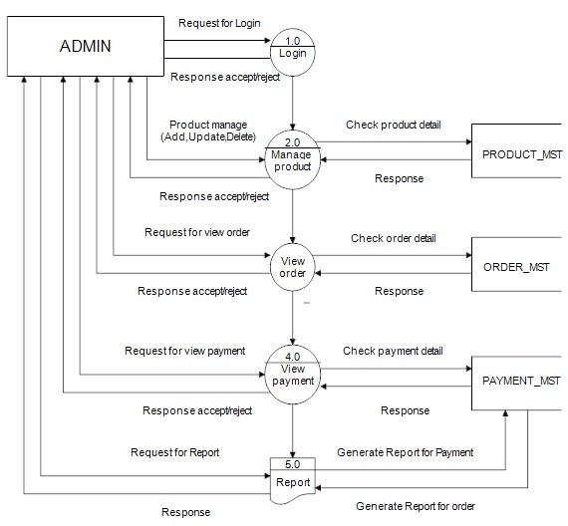

SOFTWARE REQUIREMENTS

PHP: Hypertext Pre-processor is language which began for developing web applications, is also a general-purpose programming language. PHP code is executed in a given order where it is first started by a PHP interpreter, which is then implemented as a web server module. The output of both of the interpreted and executed PHP code is combined by web server, which may be any type that is associated with the created web page [6].

MySQL: It is an open source relational database management system (RDBMS). MySQL is the central component of the WAMP open-source web application software stack. WAMP is an acronym for "Windows, Apache, MySQL, [7] and Perl/PHP/Python". From source code MySQL can be built and installed manually, but it is always installed from a binary package due to customization. Although further steps is required to alert the security and optimization settings.

HARDWARE REQUIREMENTS

A desktop computer with Intel Core i3 64 bit processor and Graphic card 1 GB RAM, and Microsoft Windows 10 operating system was used.